**Code Review:**

**Code 1:-**

The format of my navigation bar is extremely primitive and can greatly be improved through CSS.

Previous code snippet-

Current outcome-

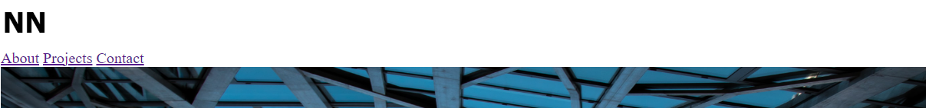

Desired outcome-

I wanted to improve the structure of my top navigation bar by formatting it correctly and making it static so that it doesn’t scroll down with the page. I also wanted it to be transparent on the homepage to allow the image in the back be visible.

New code snippet-

The new code snippet doesn’t contain any changes in the html code but includes an entirely new section of CSS code.

Update outcome-



**Code 2:-**

The section of the upper fold region looks inadequate and this can be fixed with some image formatting though CSS.

Current code snippet-

Current outcome-

Desired outcome-

I need the text on the bottom to be aligned towards the middle of the image, and I need to it to be in white to create good contrast. I also need the image to cover the entire viewport.

New code section:

The new code snippet doesn’t contain any changes in the html code but includes an entirely new section of CSS code.

Updated outcome-

